**VPC Overview**

**What is a VPC?**

* Think of it as a virtual data center in the cloud.

**VPC AWS definition.**

* Amazon Virtual Private Cloud (Amazon VPC) lets you provision a logically isolated section of the Amazon Web Service (AWS) Cloud where you can launch AWS resources in a virtual network that you define. You have complete control over your networking environment, including a selection of your own IP address range, creation of subnets, and configuration of route tables and network gateways.
* You can easily customize the network configuration for your Amazon Virtual Private Cloud. For example, you can create a public-facing subnet for your webservers that has access to the internet, and place your backend systems such as databases or application servers in a private-facing subnet with no internet access. You can leverage multiple layers of security, including security groups and network access control lists, to help control access to Amazon EC2 instances in each subnet.
* Additionally you can create a Hardware Virtual Private Network (VPN) connection between your corporate datacenter and your VPC and leverage the AWS cloud as an extension of your corporate datacenter.

**VPC Diagram:**

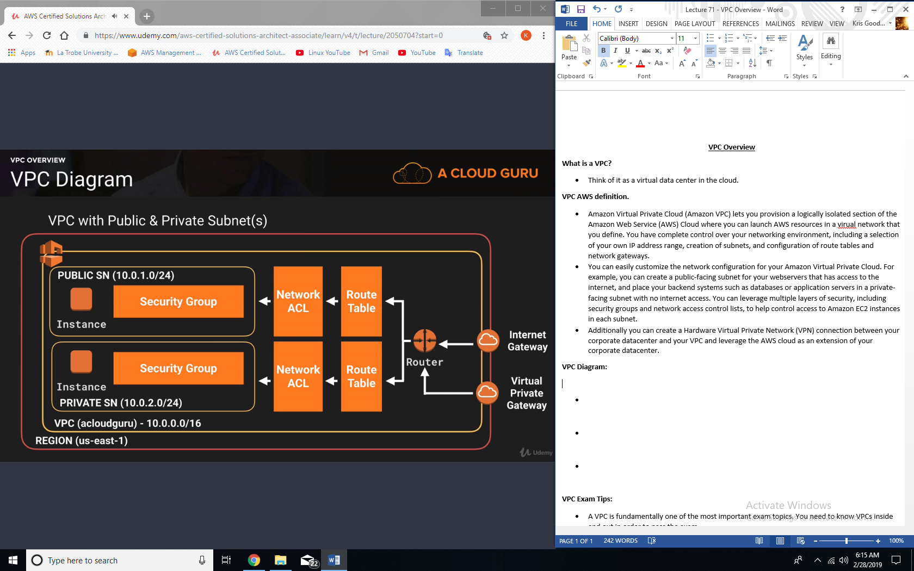

**Interactive IP address and CIDR range visualizer:**

* [CIDR.xyz](http://cidr.xyz/)
  + Great for planning out VPC architecture without having to worry about subnetting.

**What can you do with a VPC?**

* Launch instances into a subnet of your choosing.
* Assign custom IP address ranges in each subnet.
* Configure route tables between subnets.
* Create internet gateway and attach it to our VPC.
* Much better security control over your AWS resources.
* Instance security groups.
* Subnet network access control lists (ACLS)

**Default VPC vs Custom VPC:**

* Default VPC is user friendly, allowing you to immediately deploy instances.
* All subnets in default VPC have a route out to the internet.
* Each EC2 instance has both a public and private IP address.

**VPC peering:**

* Allows you to connect one VPC with another via a direct network route using private IP addresses.
* Instance behave as if they were on the same private network
* You can peer VPC’s with other AWS accounts as well as with other VPCs in the same account.
* Peering is in a star configuration: i.e. 1 central VPC peers with 4 others, NO TRANSITIVE PEERING!

**VPC transitive peering:**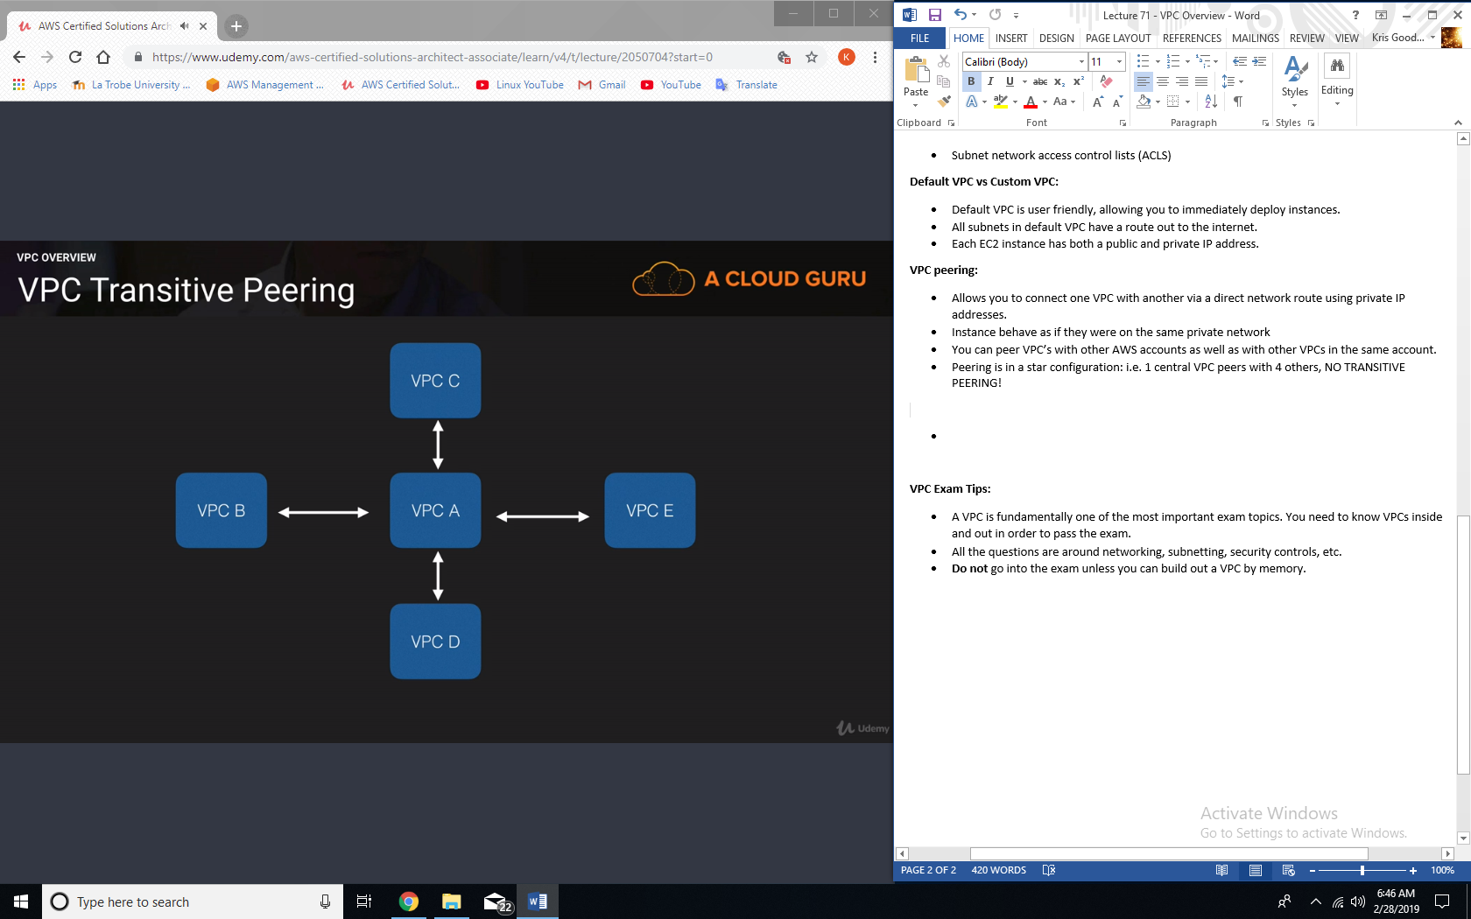

**VPC Exam Tips:**

* A VPC is fundamentally one of the most important exam topics. You need to know VPCs inside and out in order to pass the exam.
* All the questions are around networking, subnetting, security controls, etc.
* **Do not** go into the exam unless you can build out a VPC by memory.
* Think of a VPC as a logical datacenter in AWS.
* Consists of IGWs (Virtual Private Gateways), route tables, Network Access Control Lists, subnets and Security groups.
* 1 subnet = 1 availability zone
* Security groups are stateful; Network access control lists are stateless
* NO TRANSITIVE PEERING!